**Airbnb Price Prediction**

**Group 15**

**Niral Desai**

**Vikrant Shelke**

**Case Study Documentation**

**Background**

AirBnb is a San Francisco based company that offers an online marketplace for booking short-term lodging and experiences. It acts a middleman and takes a cut of each transaction. The company was created back in 2008 by Brian Chesky, Nathan Blecharczyk, and Joe Gebbia.

AirBnb is a platform that connects local homeowners with travelers looking for unique and affordable accommodations options. Hosts can earn extra income by renting out their homes or rooms and have access to millions of potential guests worldwide. The platform offers a secure and streamlined booking process and support for both hosts and guests. For travelers, host offers a wide range of accommodations, from cozy cottages to luxurious penthouses, for any type of trip, whether it be for work, a weekend getaway, a family vacations, or an extended stay. With millions of options to choose from, there is a perfect place for every traveler.

**Problem**

As there is no simple way to obtain the information, figuring out the ideal rental pricing for and AirBnb listing can be difficult for hosts. Although it is offered through various third-party software, but it can be very pricey. Finding comparable listings in the neighborhood and averaging their prices is a common strategy, but it is not always reliable and necessitates frequent updating.

**Solution**

To estimate rental prices, our aim is to offer a data driven approach. The suggested model will incorporate a new predictor based on the property’s proximity to certain locations and enabling the model to consider the value of being situated close to facilities like train station or supermarkets or tourist spots and modify its predictions accordingly.

**Data Description**

We were searching for a specific type of dataset for our project, which included all the listings of currently available places on a AirBnb marketplace. However, the website we were interested in, AirBnb, does not publicly release this type of data. Therefore, we had to turn to third-party websites such as Inside AirBnb to obtain information. These sites offer real-time data, but obtaining it was time-consuming process and came at a cost. As a result, we had to settle for a free dataset from Kaggle, which was the New York City AirBnb listings dataset.

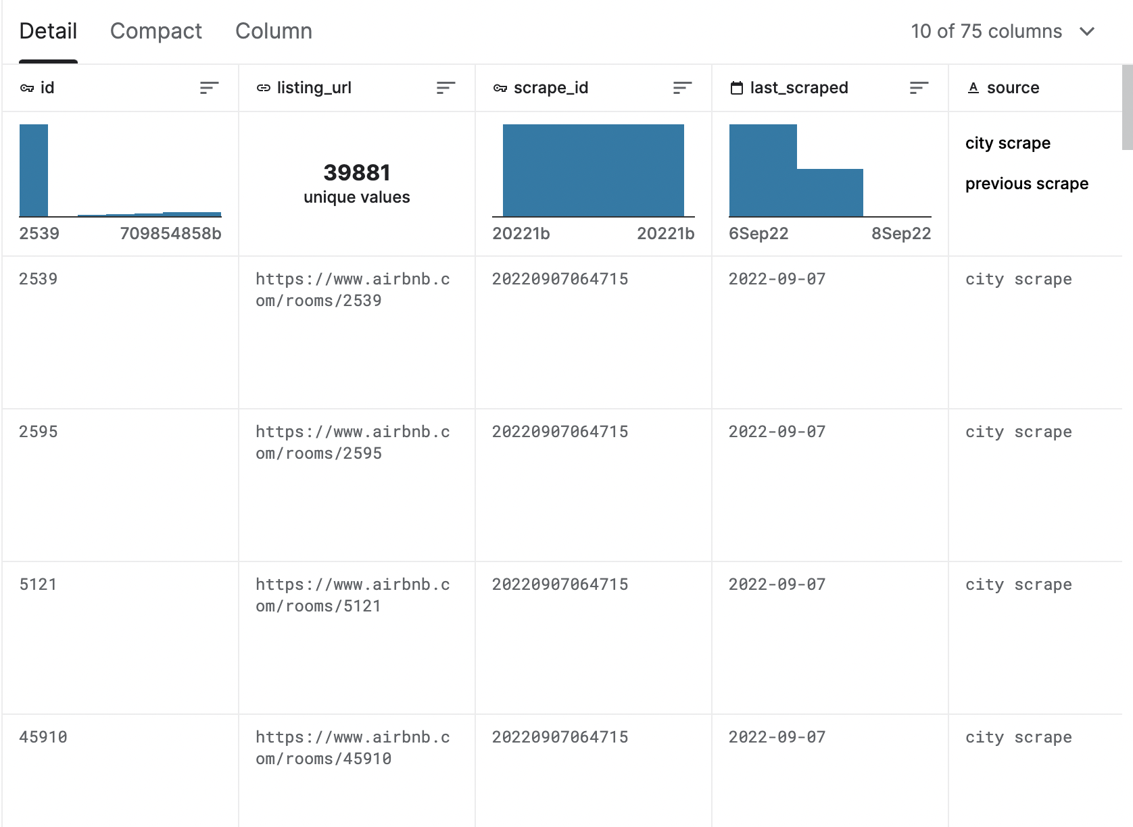

**A sample snapshot of dataset 1**

[https://www.kaggle.com/datasets/dominoweir/inside-airbnb-nyc](mailto:https://www.kaggle.com/datasets/dominoweir/inside-airbnb-nyc)

This is where we got our dataset from.

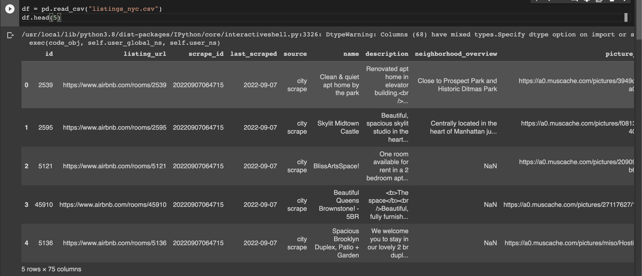

**A sample snapshot of dataset 2**

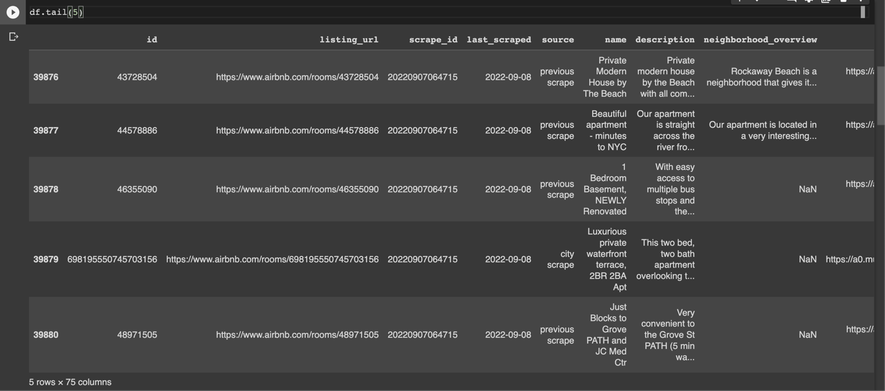

**A sample snapshot of dataset 3**

Some of the important aspects of the dataset we will be looking forward to work with are:

Last_scraped: Date on which the place is last rented out on.

Accomodates: How many people does it accommodates.

Beds/Bath: Number of beds and baths the place has.

Price: Price for the rented place.

Max_Nights: Maximum number of nights it can be rented out.

Min_Nights: Minimum number of nights it can be rented out.

Review_Score_Accuracy: Accurate review score.

Property Type: The Type of rented place is.

And there are more of these columns in our dataset

The data has various limitations, and we will be cleaning it thoroughly before actually implementing our model.

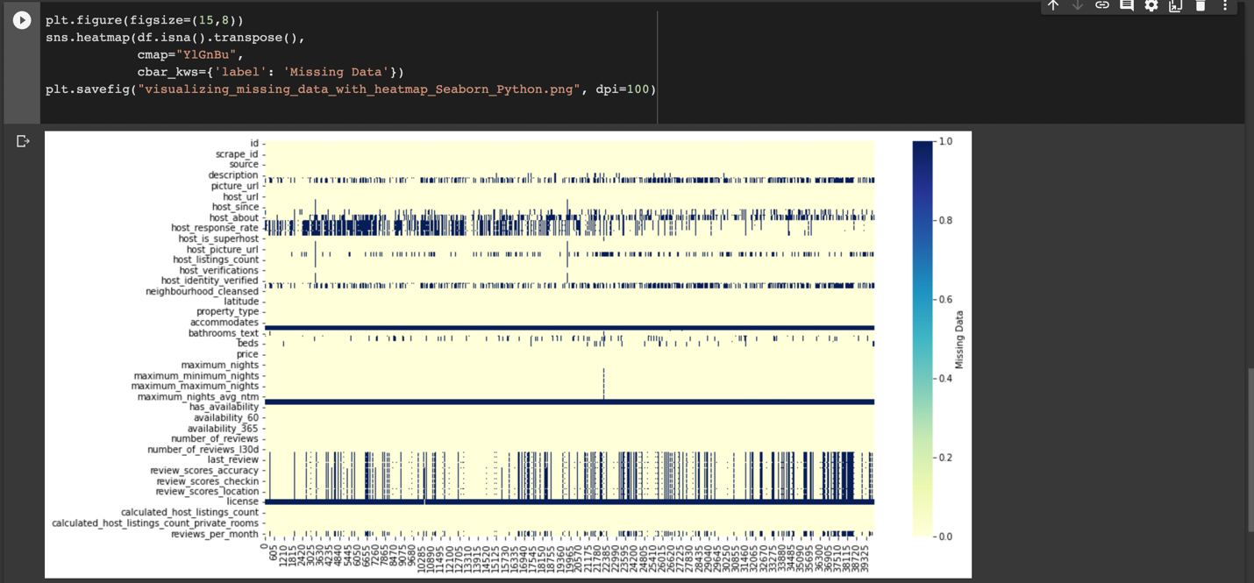

**Next Step**

Cleaning the data is crucial as the dataset contains many missing values, which should be either removed or imputed with appropriate values.

**Timeline**

**Milestone 2**

**Data Collection and Processing**



In the above figure we tried to show a heat map of missing values in the dataset.

Before we get into cleaning the dataset, we tried to figure out as much as we can about the columns and what are their correlation with each other.

**Step 1:**

To check the number and percentage of null values

For that we used isna() and isnull() to calculate percentage.

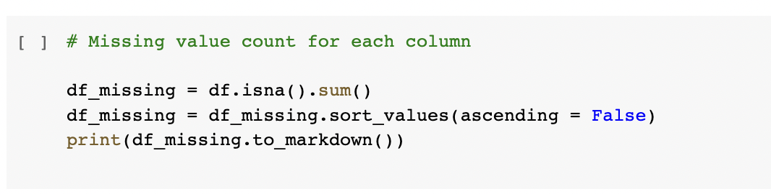

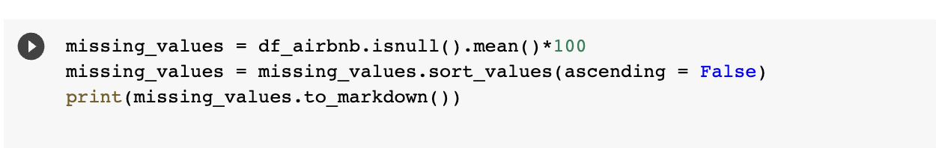

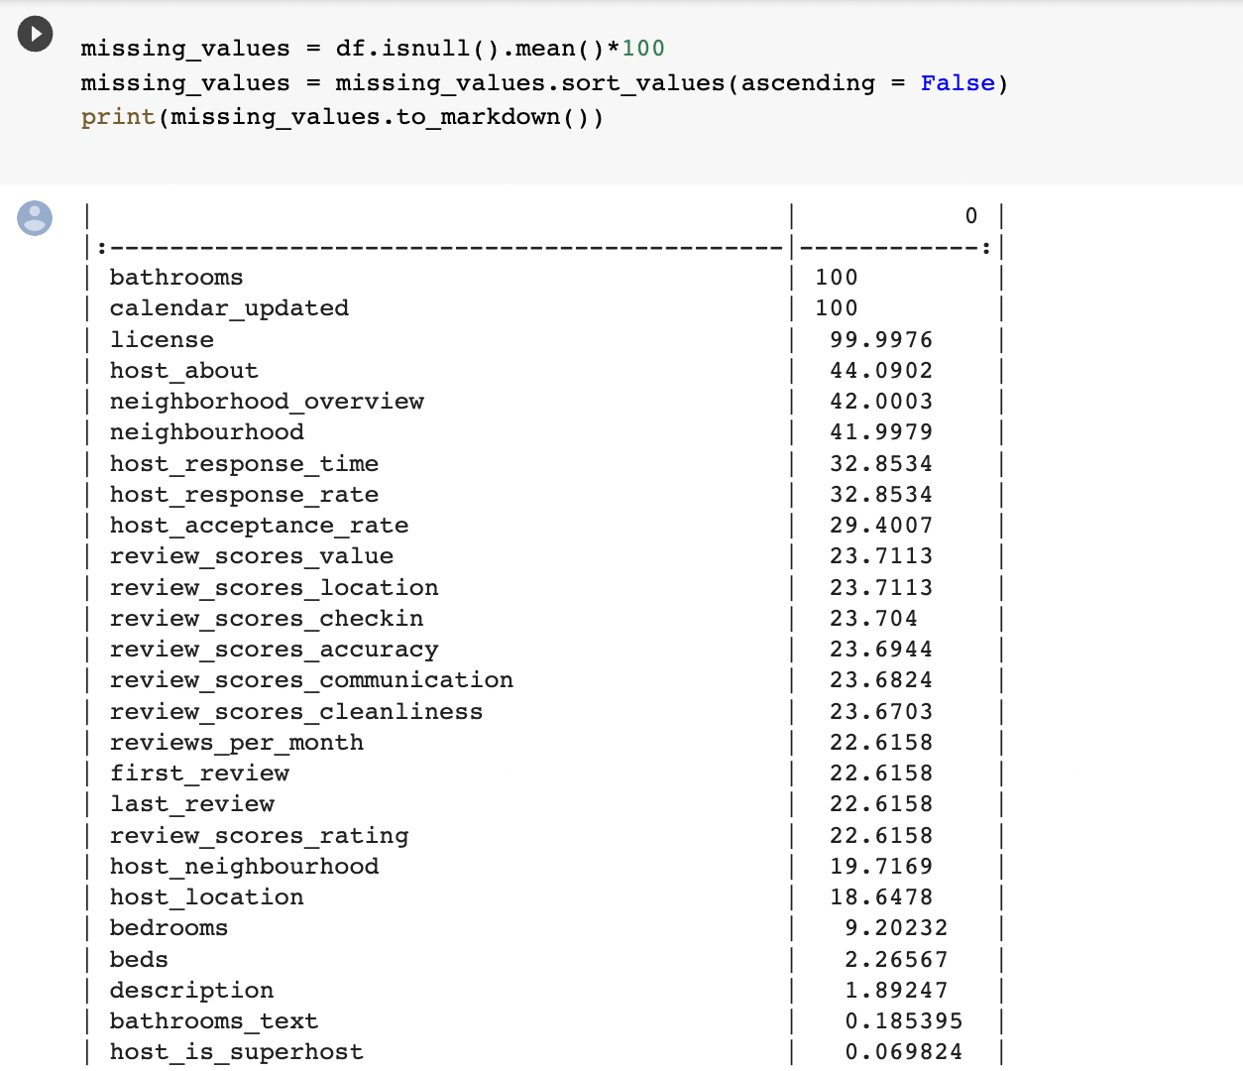

* As you can see bathroom , calendar_updated and license has the highest missing values percentage, so we will start with dropping those columns.
* But there is another column ‘bathrooms_text’, so before dropping bathroom we need to compare those two columns.
* And we found out those two columns are one and the same so we dropped bathroom.
* Now there are multiple columns with Url in it, which wont be needed in our model hence we will be dropping those, ['host_picture_url','host_has_profile_pic','host_url','picture_url','host_thumbnail_url','listing_url']
* There are few more columns which looks very similar to each other hence we dropped those columns as well
  + **host_total_listings_count** and **host_listings_count** is almost unique, so lets drop one.
  + Few of the unnecessary columns can also be dropped such as: scrape_id, last_scraped, host_verifications, host_identity_verified.
  + **maximum_nights_avg_ntm**,**minimum_nights_avg_ntm,maximum_maximum_nights**,**minimum_maximum_nights,maximum_minimum_nights**,**minimum_minimum_nights**,**minimum_nights**,**maximum_nights**.It doesnt makes sense to keep all of this. Hence we will be keeping **minimum_nights** and **maximum_nights** only.
* The above list of columns are just few of those that need immediate removal for the rest of the columns we need to check each and every single one.



* We saw there are lot of columns regarding the neighborhood so we investigated that to see what might help us predicting the price.

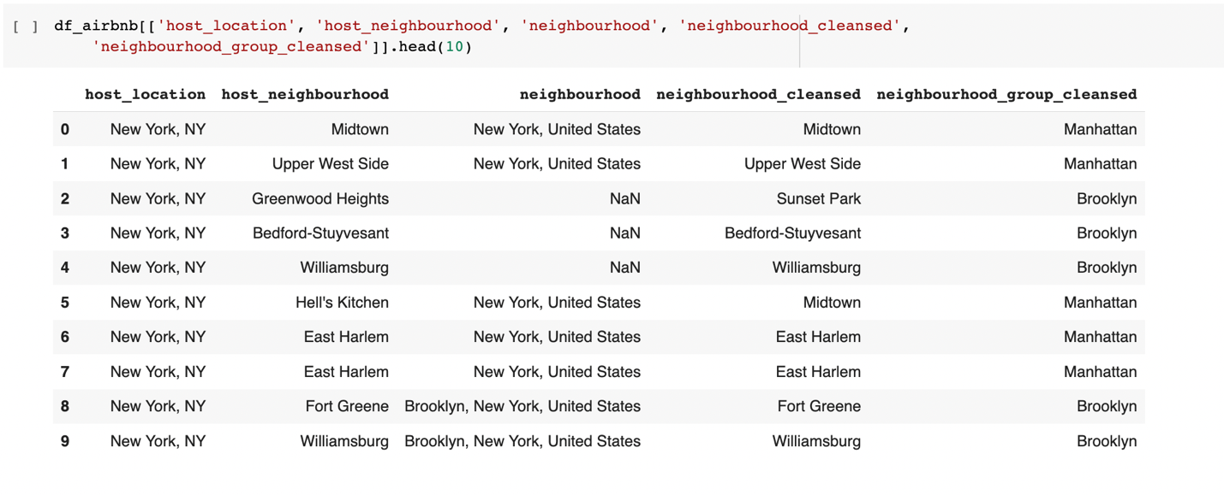

* + Since this dataset only contains New York listing there is no need for host_location, hence we will be dropping that
  + Next host_neighborhood and neighborhood_cleansed seems to be giving the same information we will be dropping one of these.
* We don’t think as of now there is any more columns that we need to drop apart of few that me might be dropping later because as of now we don’t really know if those columns might affect the prices, hence we will keeping those columns.

**Step 2:**

* To check for special characters in the columns
* Few of the columns had % and $ sign hence we will be imputing those special characters
* Also, there were some datetime columns that we will change to weeks for feature engineering

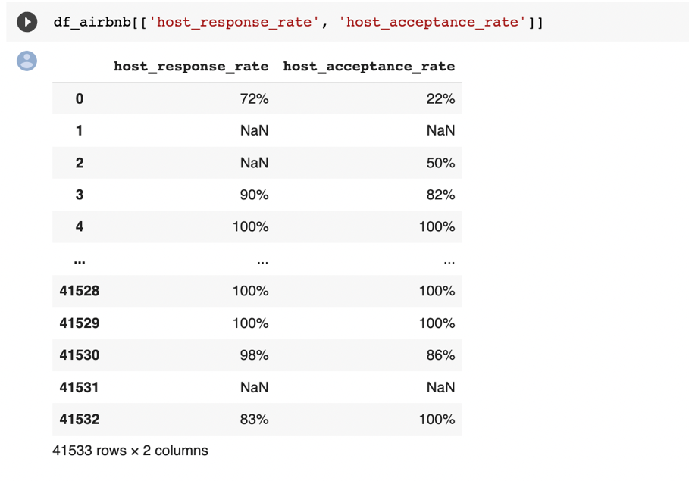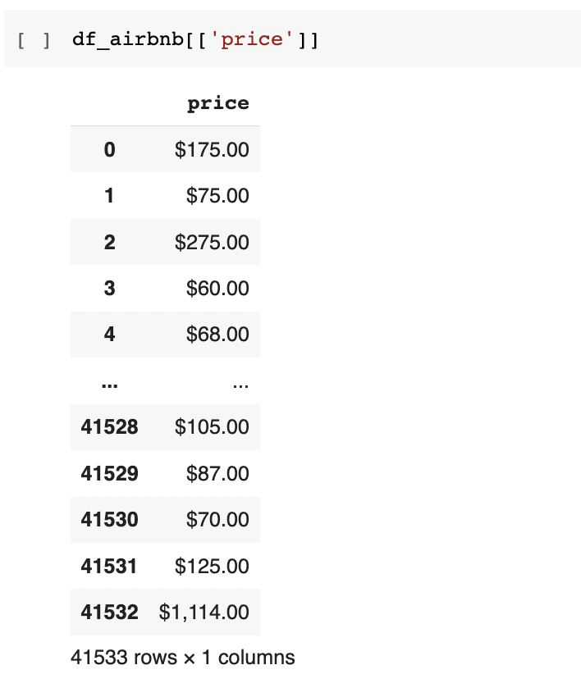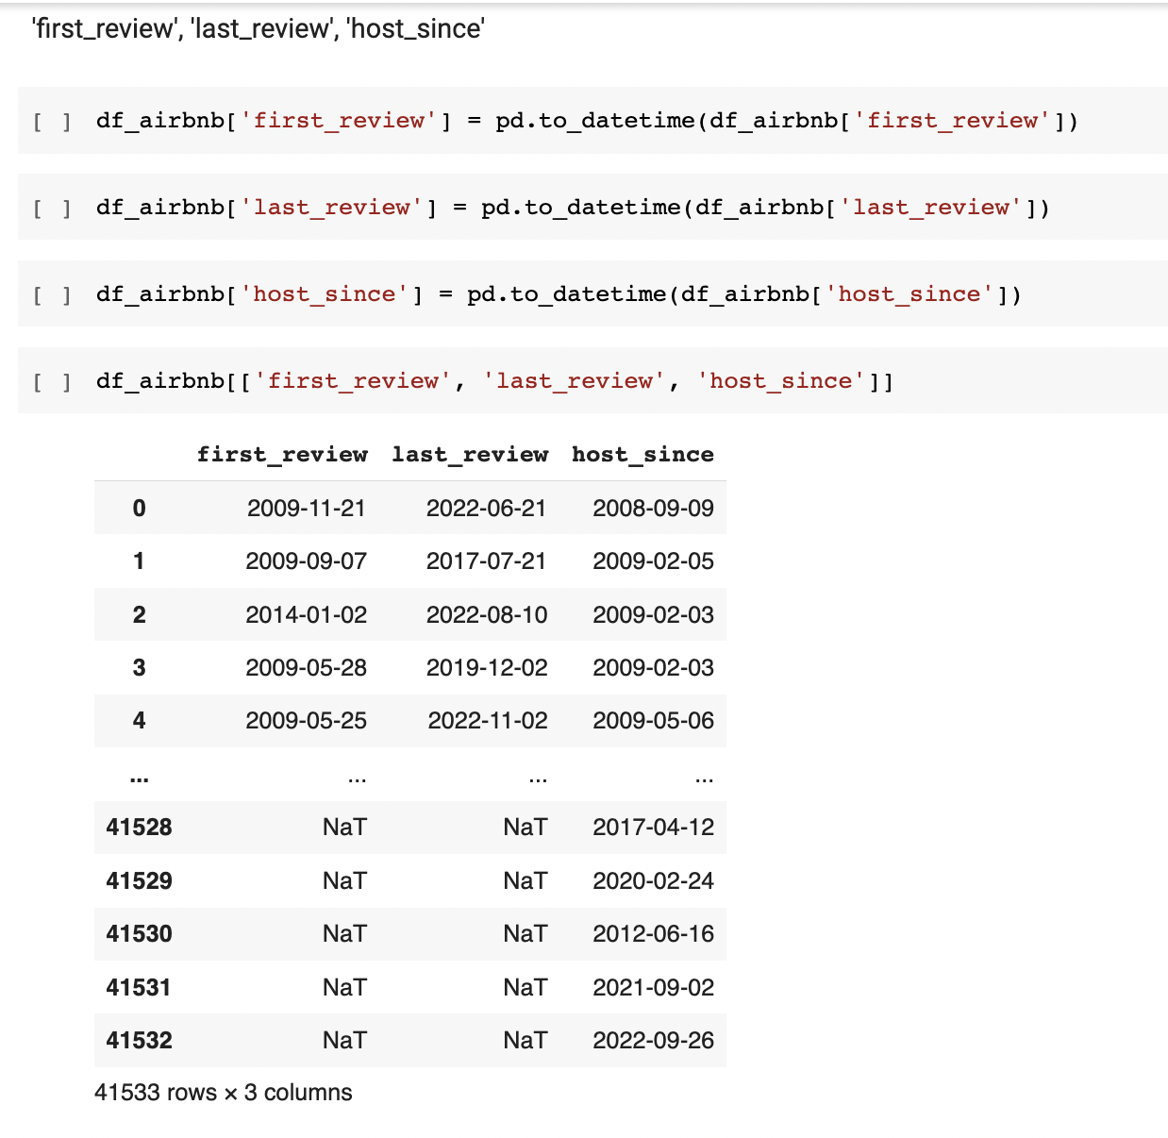

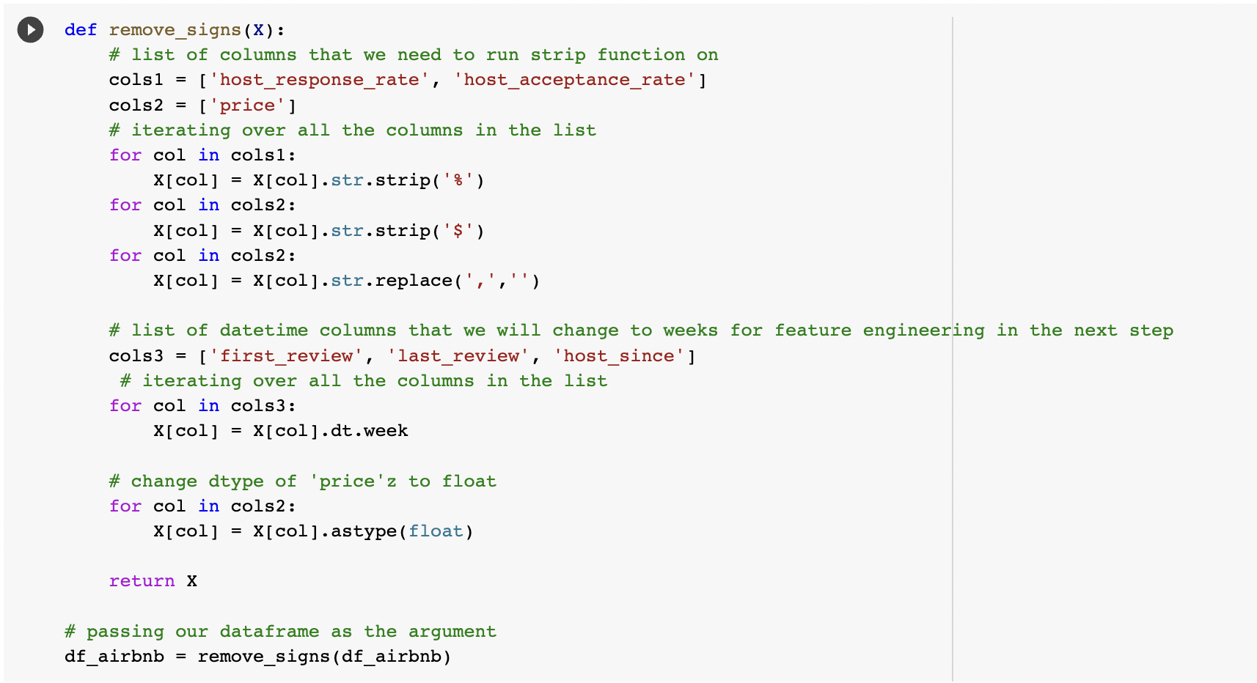

**Milestone 3**

**Data Exploration and Visualization**

First we tried to figure out various columns that might me affecting our target variable ‘Price’, we were curious to look at histogram plots and scatter plots for finding meaning full insights hence we divided different variables to compare it with our target variable

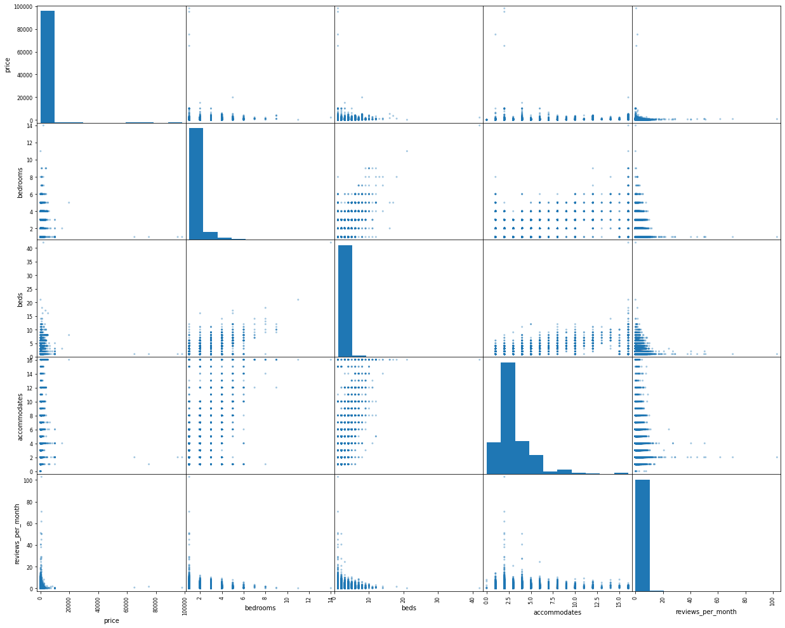

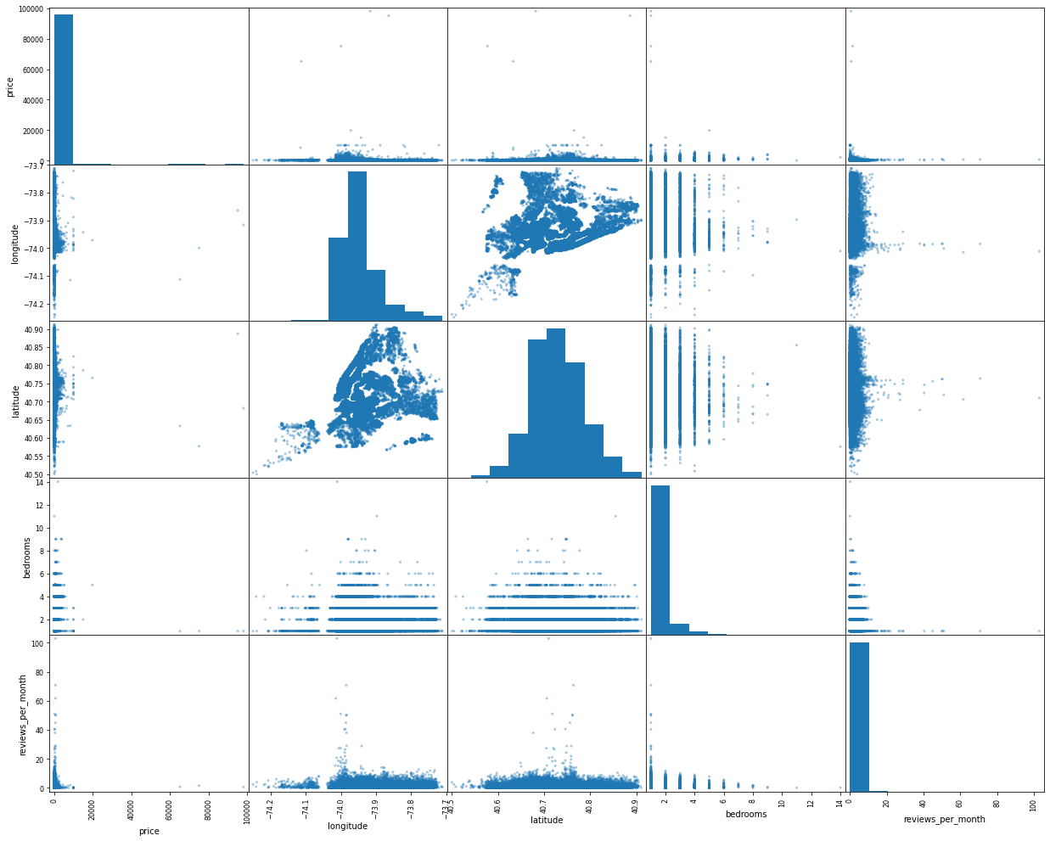

Observations :

* Dataset has a lot of outliers.
* And out target variable is highly skewed.
* Few other variables are highly correlated with our target variable.

Hence, we tried to handle outliers.

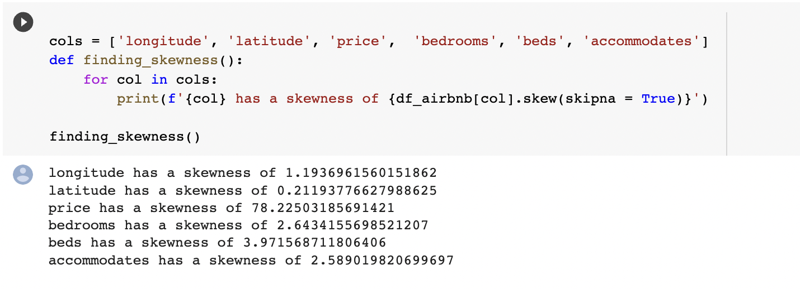

* As you can see price has a whooping skewness of 78.22 which is a very big problem hence, we will be solving that issue by either carefully filtering out the outliers by looking at the boxplot
* We can also solve this baking taking log of price into account.

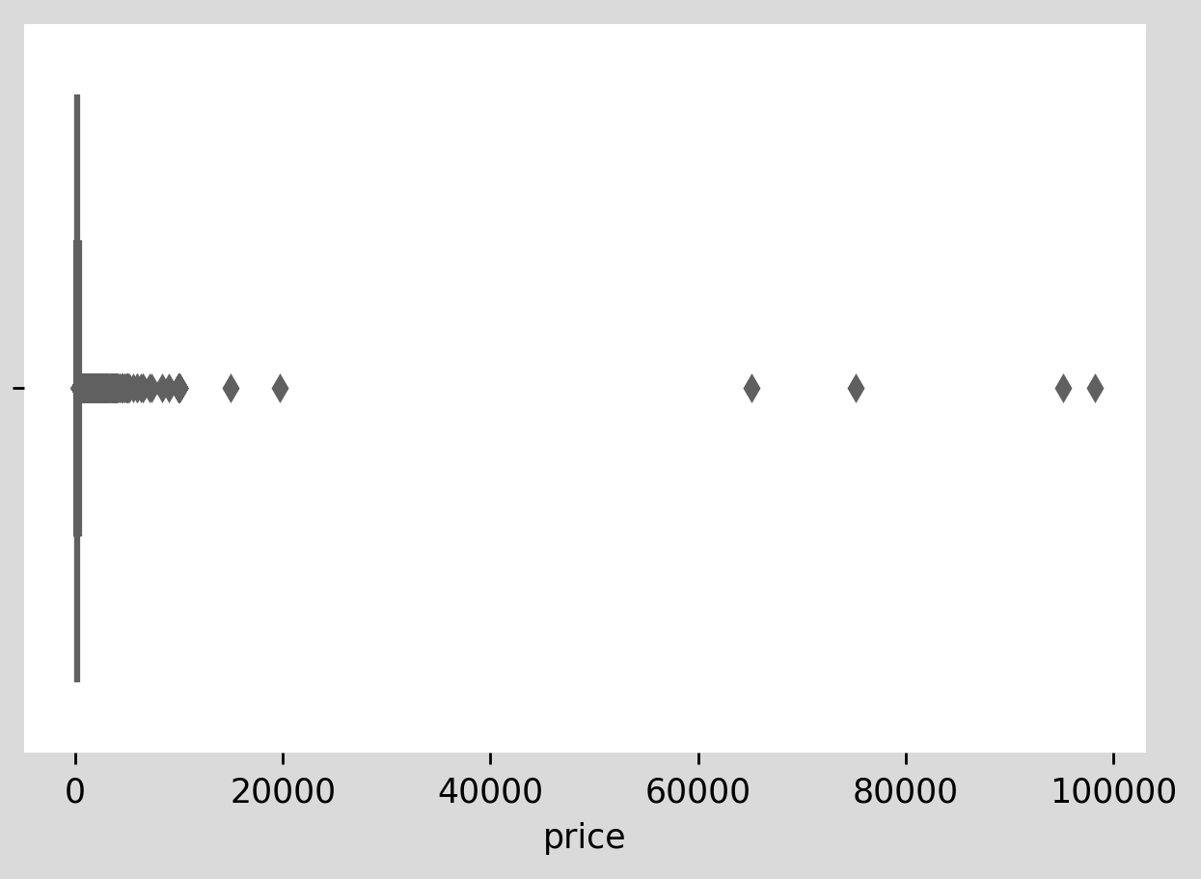

It is hard to believe that prices could go as high as 100000.

Let’s look at the prices with the range of 0 to 1000.

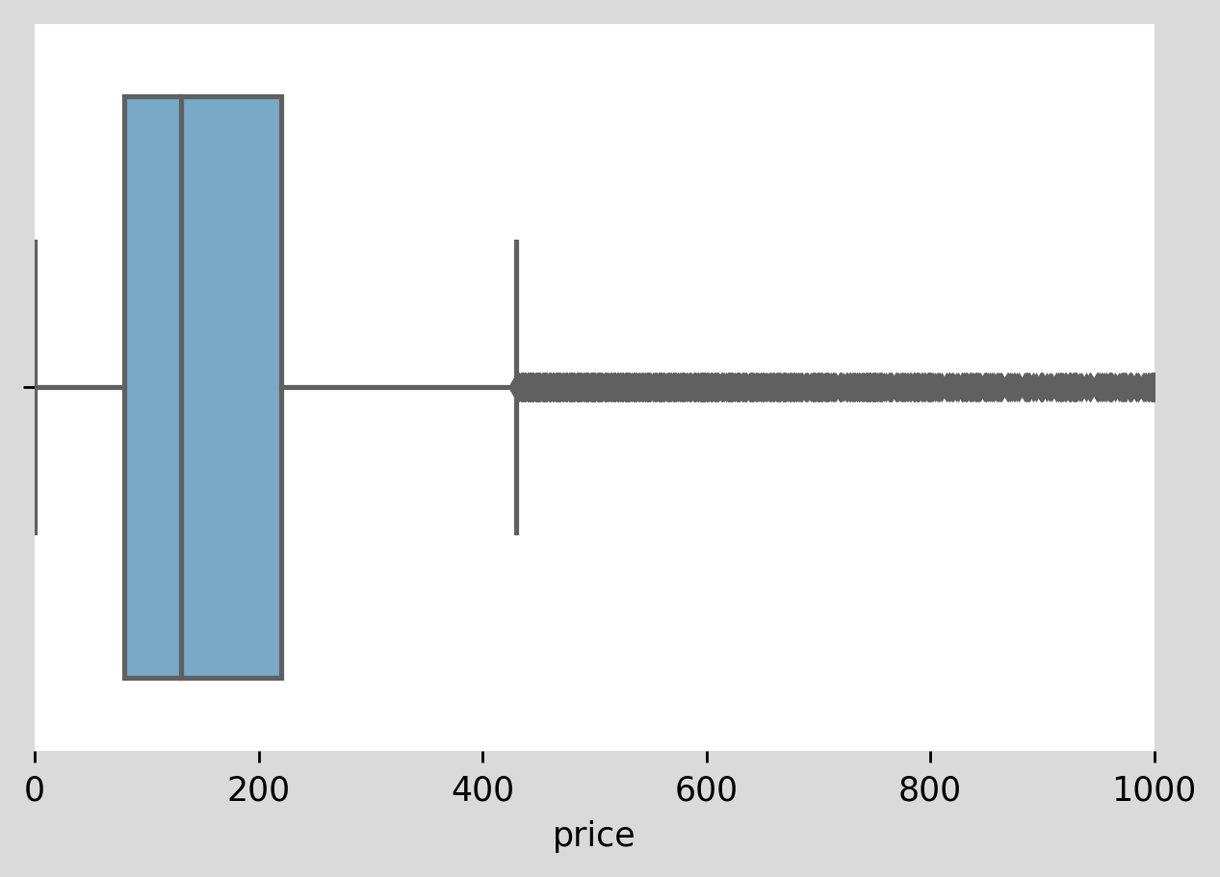

Hence to get rid of the majority of the outliers we will use prices with the range of 0 to 1000.

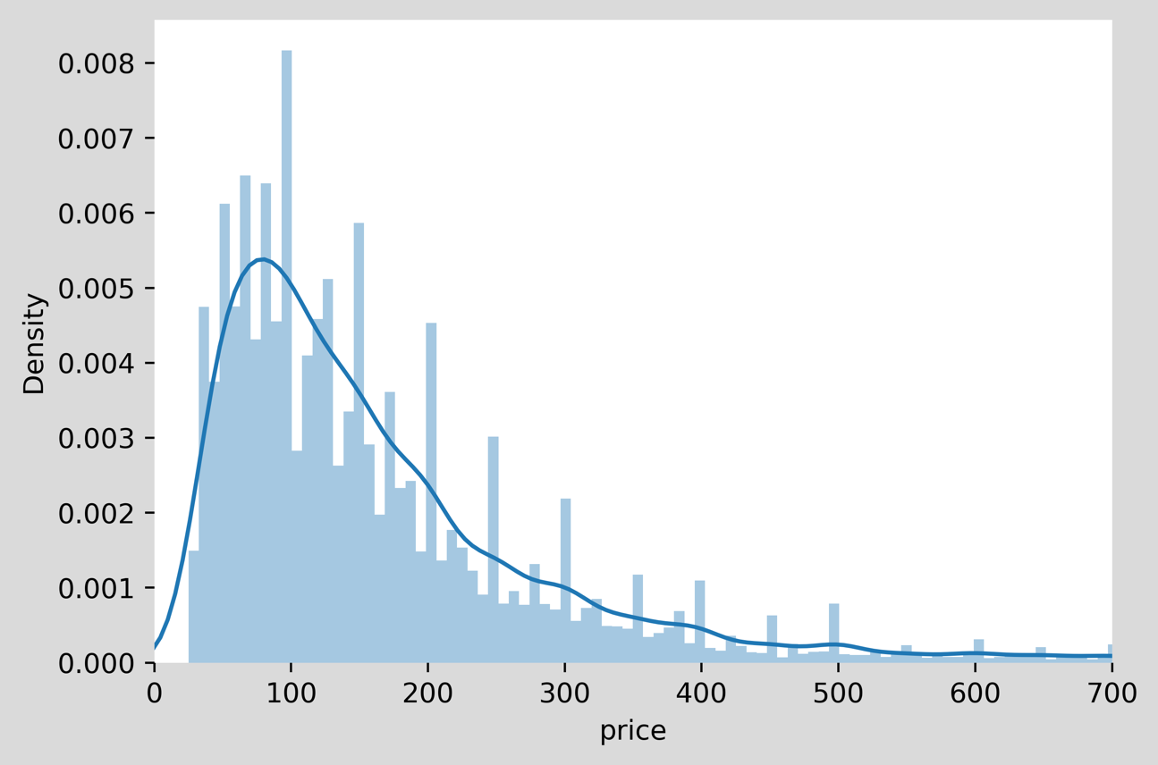

This looks much better with majority of the outliers handled.

Let’s look at the correlation matrix and see if we can find meaningful insights.

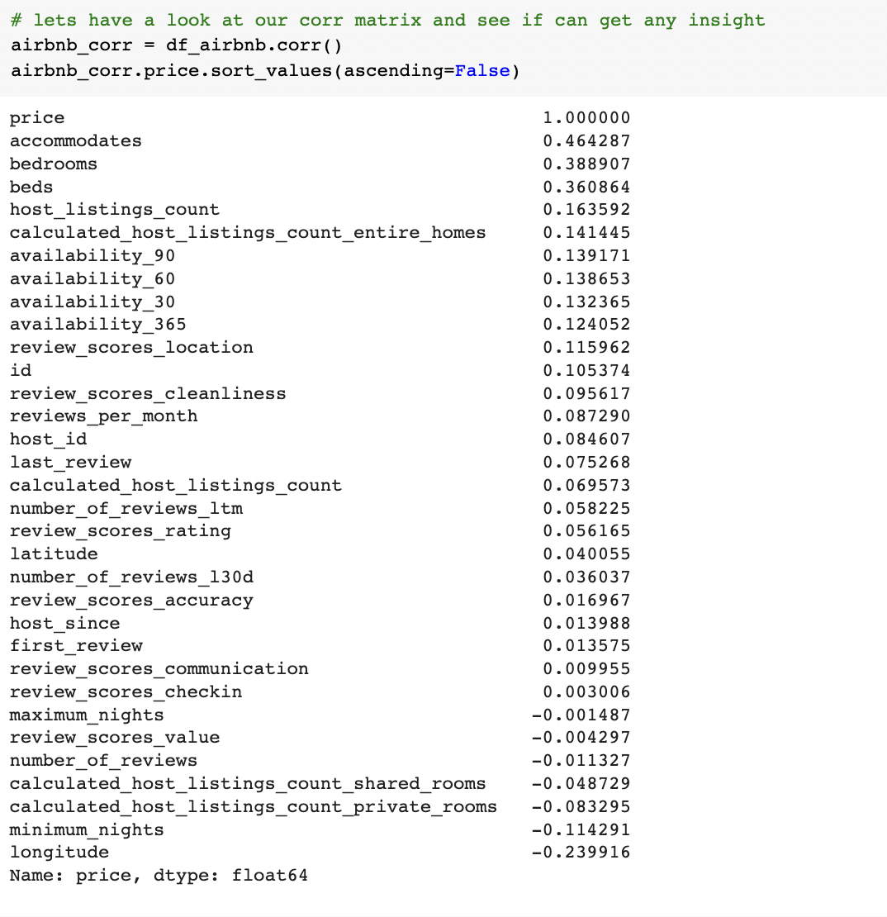

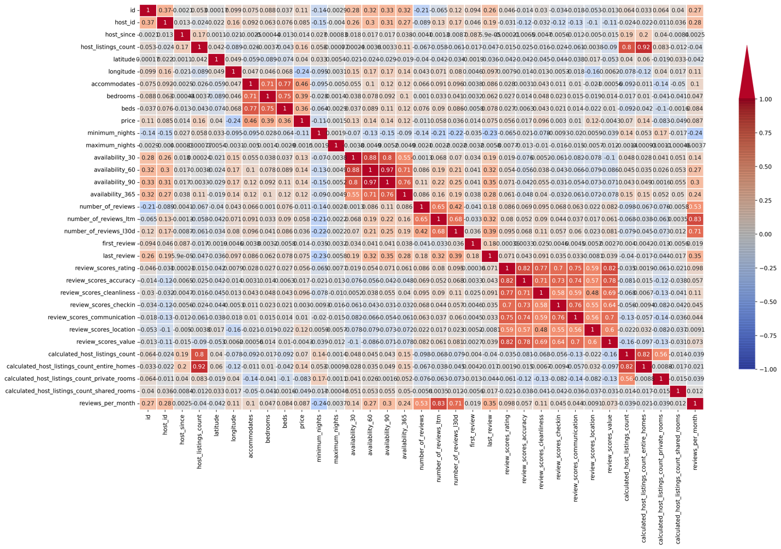

By looking at the heatmap we can say that there are still a lot of columns that we can remove because some of them are highly correlated.

One another insight we can get is by looking are the prices with respect to number of bedrooms as it greatly affects the price.

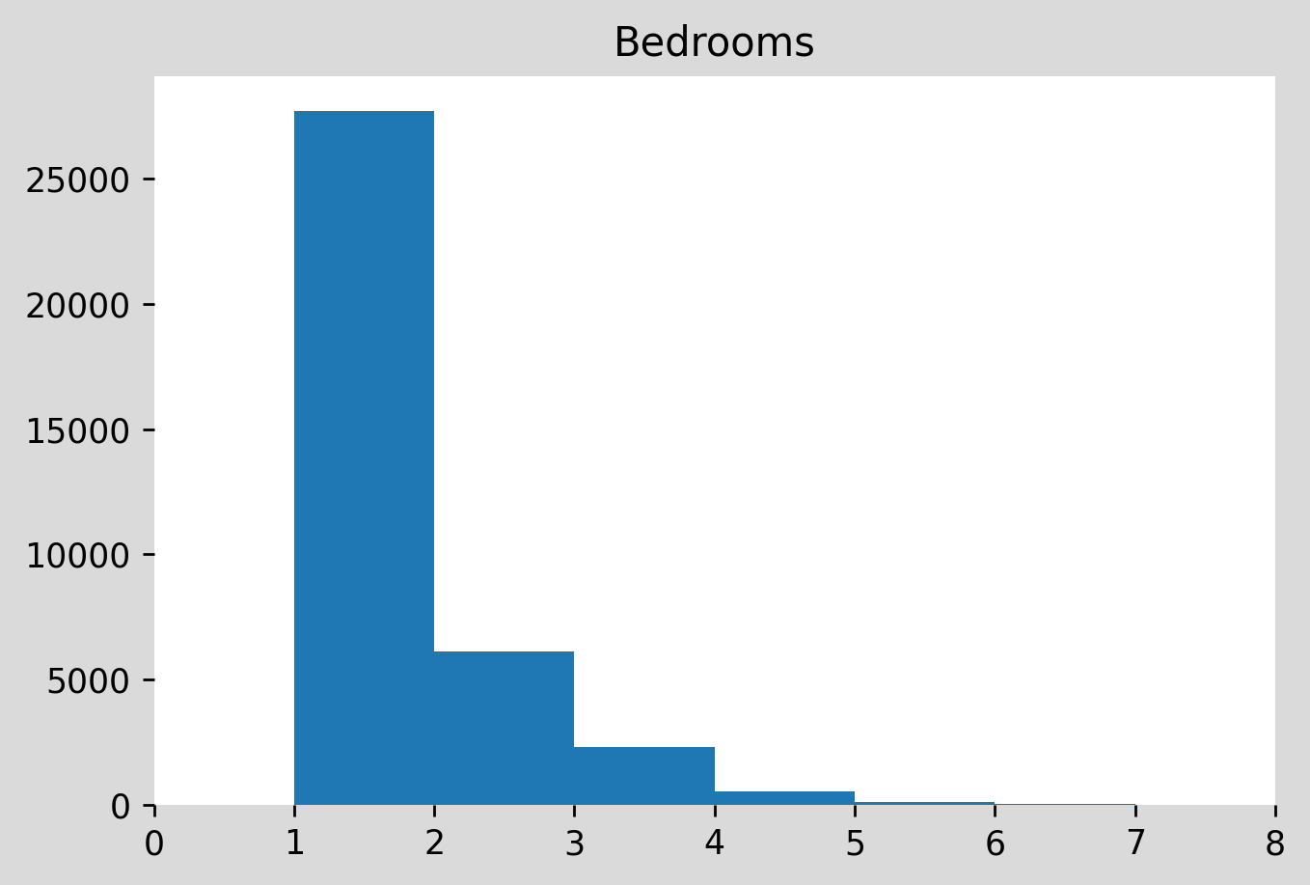

We will be grouping these reviews into bins hence let’s look at it.

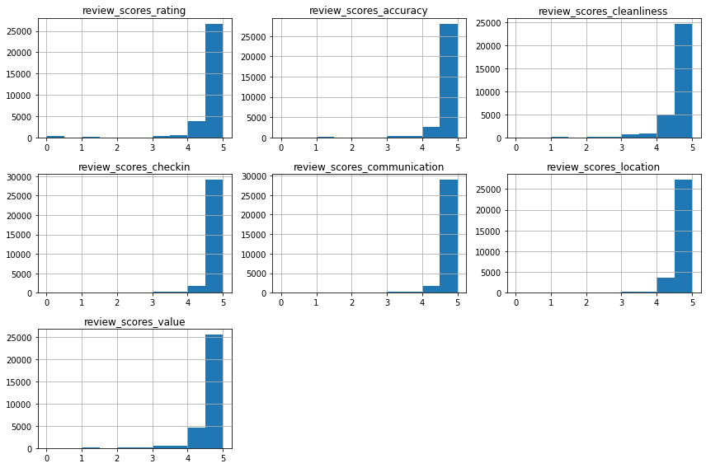

Let’s find out if a AirBnb host is still on the listing.

For that we will check for dates between 2010-08-21 and 2023-01-01  
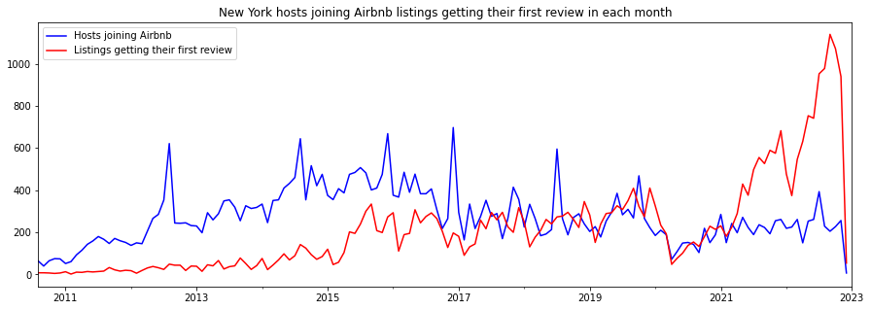

It is important to also consider the frequency of listings per host when analyzing Airbnb Data. As there are many professional managements company that may have numerous listings under single host profile.

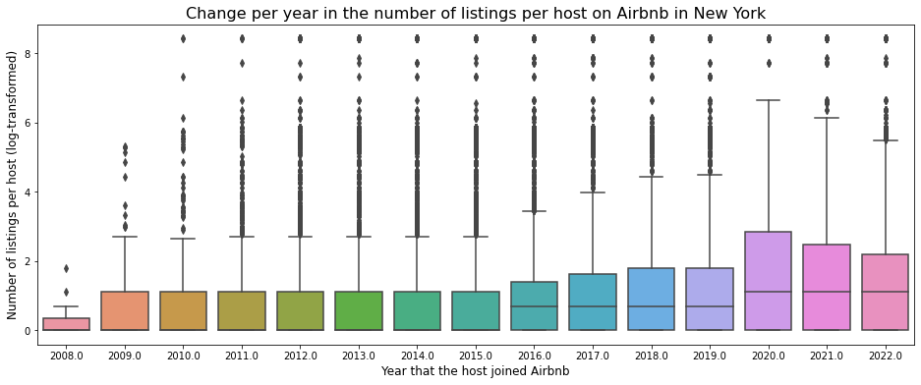

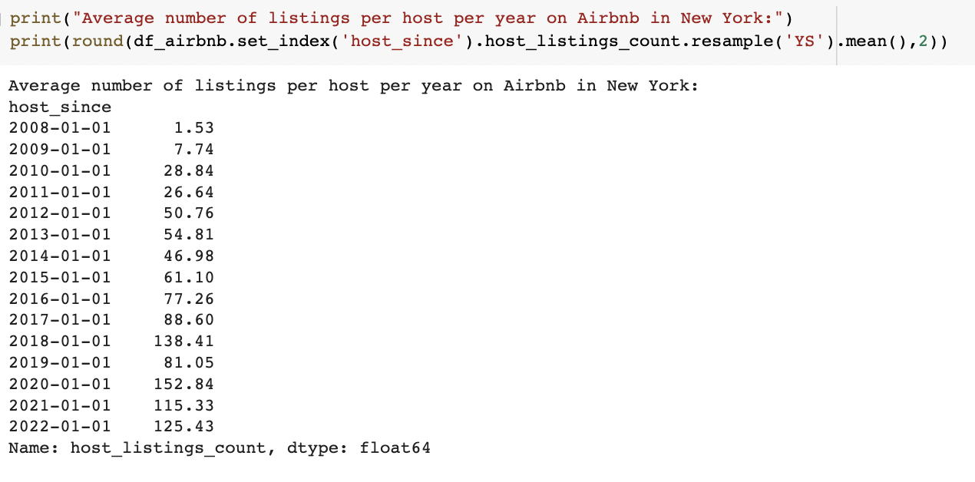

Now, we extracted the information from the **frequency distribution** table of the **room_type** variable and generated a bar chart comparing the frequency of each category, thus making it easier to understand how these categories are distributed.

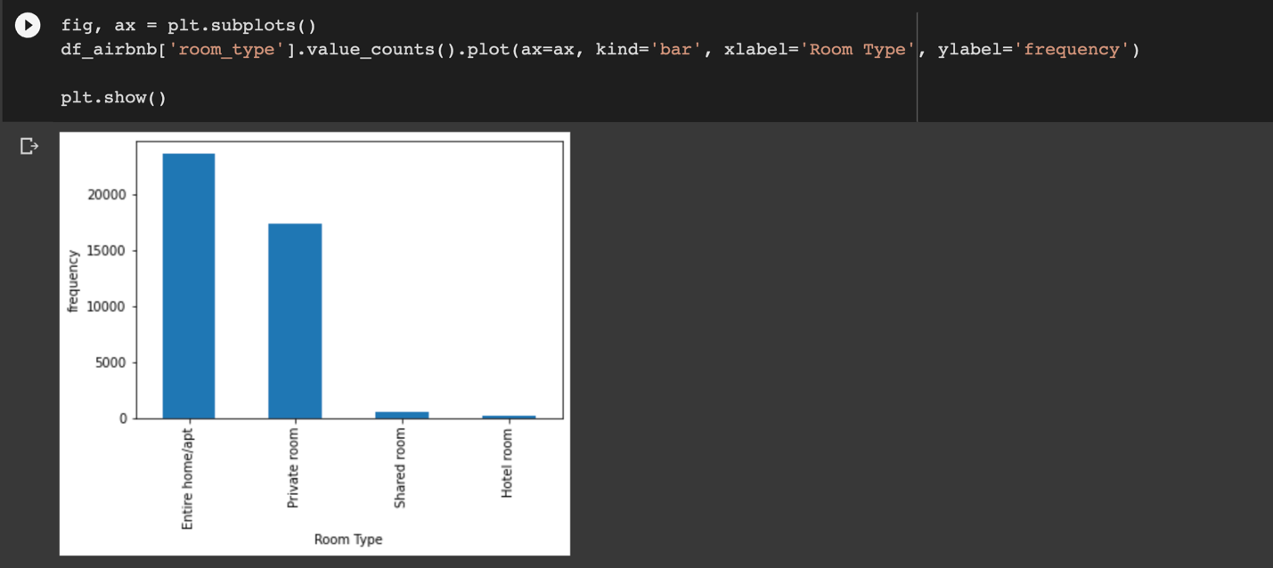

Entire apartments and private rooms dominate the Airbnb market in New York City. Hotel rooms are basically nonexistent.

Now let's see the average prices for each of these room types.

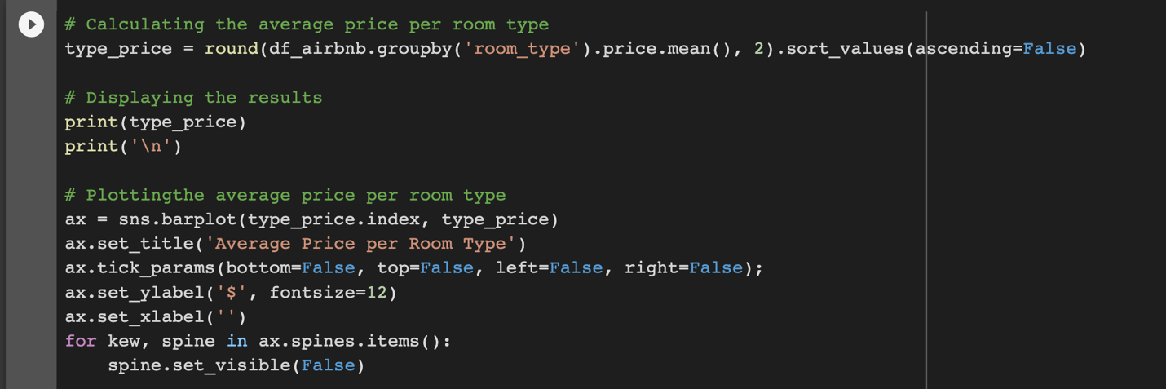

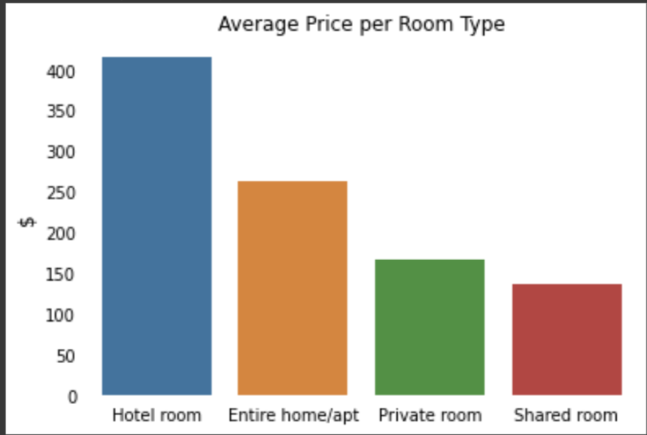

Hotel rooms are the most expensive type of room, on average. This might happen for two reasons:

* Hotels are naturally more expensive because of the number of employees and the services and options available to the guest, such as room service and parking spots.
* There are fewer hotels in the dataset, which distorts the average.

Other than that, it is reasonable to think that entire apartments are more expensive than private rooms and that private rooms are more expensive than shared rooms.

Now that we already have some information about the price distribution for rooms in New York City, let's visualize this data geographically and try to determine which points of the city present higher and lower average prices on Airbnb.

First, we'll create a scatter plot using the latitude and longitude columns of our dataset.

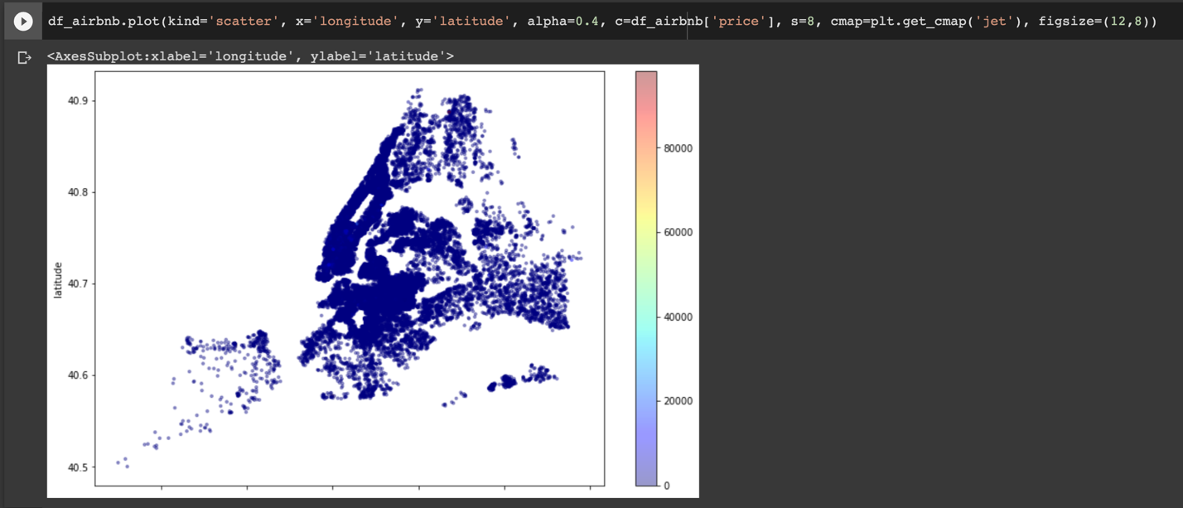

As New York is one of the most famous cities in the world, we can see some patterns. For example, we can identify the island of Manhattan and we can see Central Park, the white square in the middle of the island.

The prices in Lower Manhattan are higher than most of the other regions on the map. The region around the Brooklyn Bridge presents some higher values and we can see some very high values on the east side of Queens too.

**Milestone 4**

**Model Exploration and Selection**

Before we get into model exploration and selection there, we few things that needed to handle,

* Our target variable had a lot of skewness, we were able to bring it down to some points and the rest we will take care of it by using log in the models.
* We created bins for bedroom as it was in correlation with our target variable.
* Since we were interested in amenities, we created a new column with various sorts of amenities.

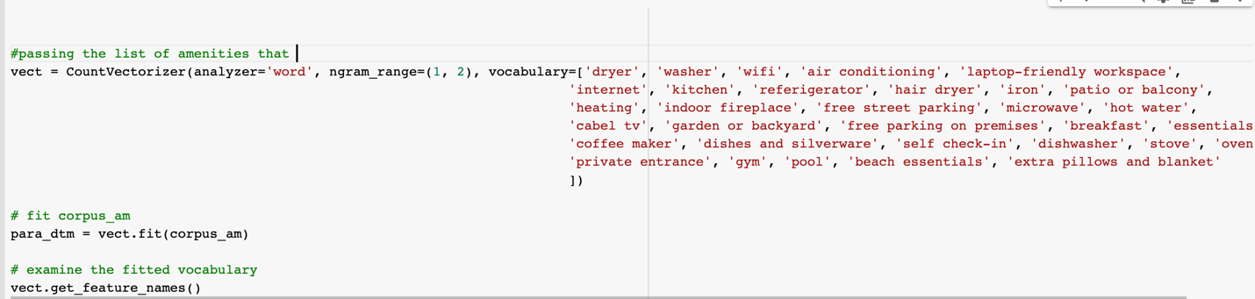

**Baseline model**

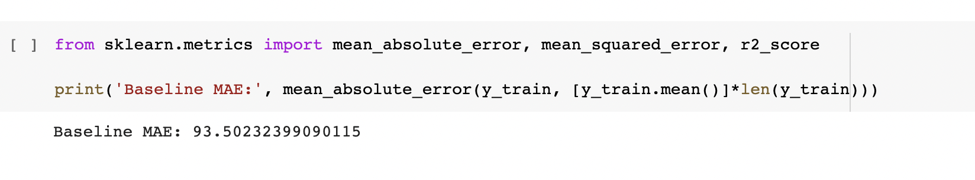

Let’s start with implementing different models.

**Linear Regression**

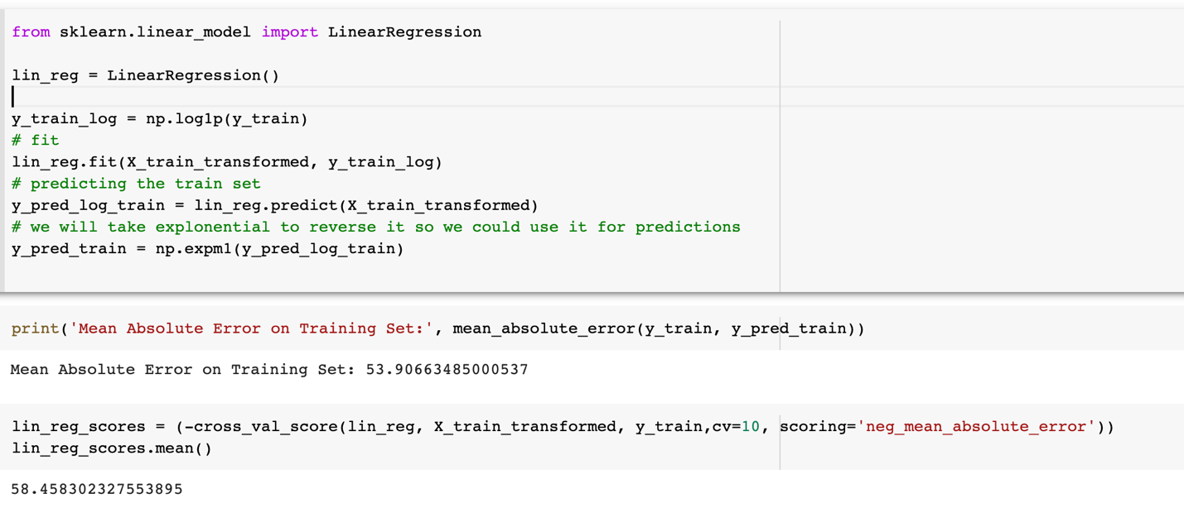

**Random Forest Regressor**

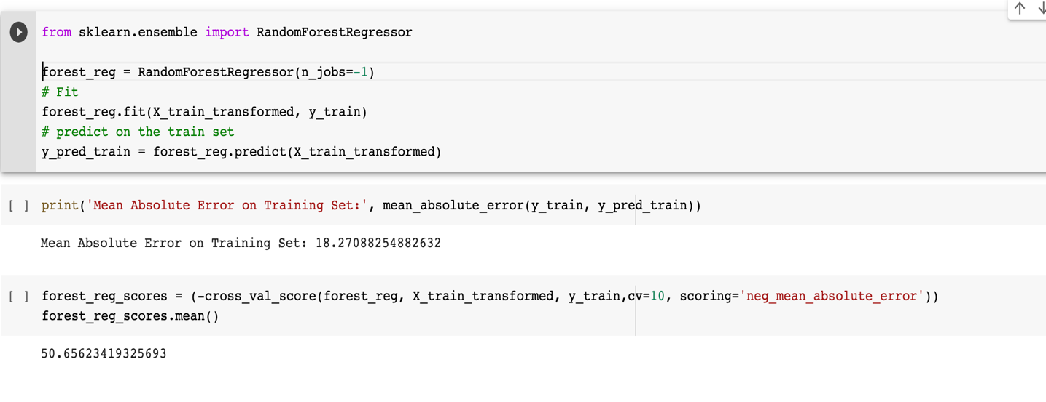

**Gradient Boosting Regressor**

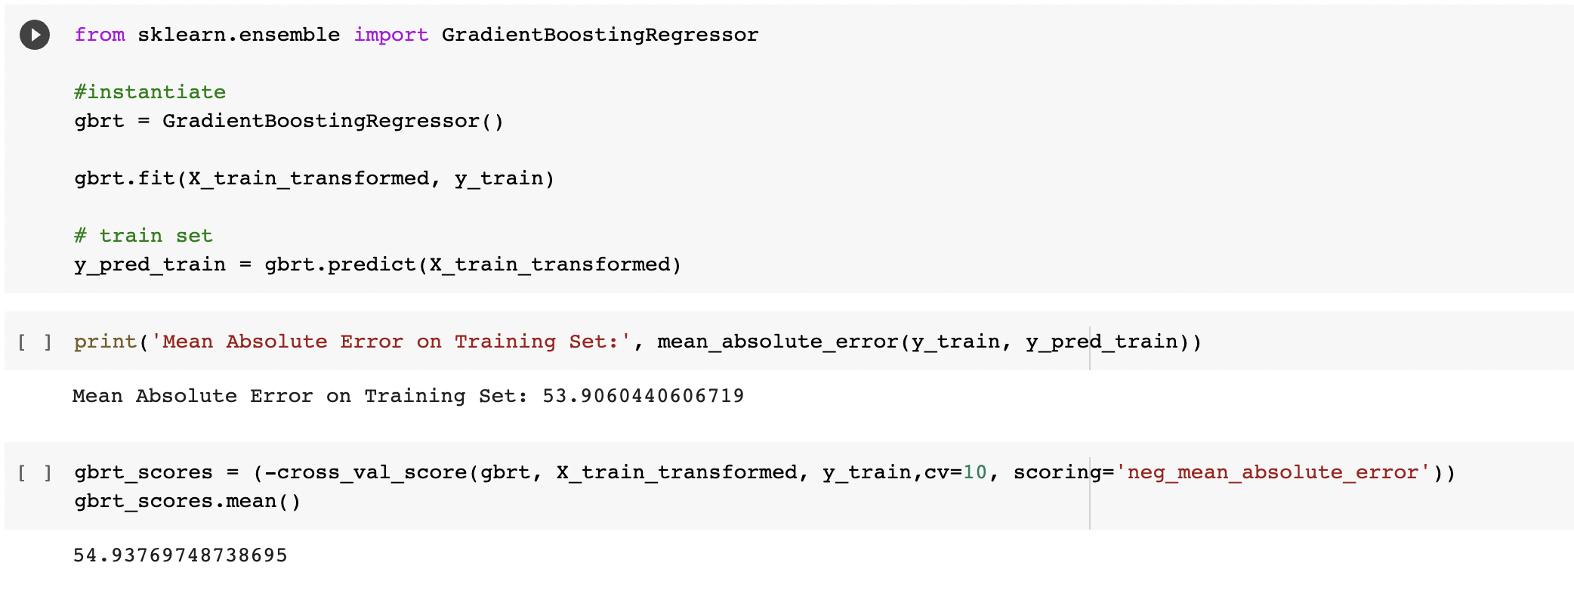

**Support Vector Machine Regressor**

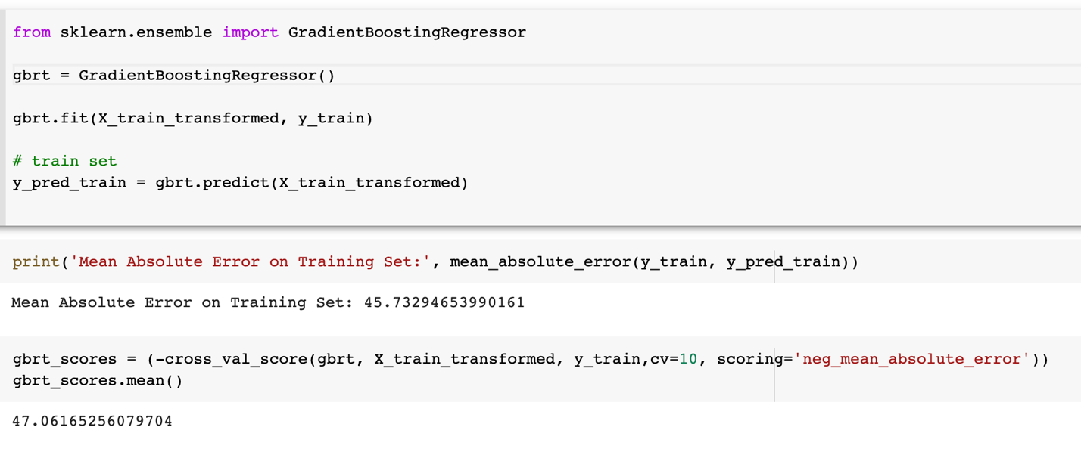

**Linear SVR**

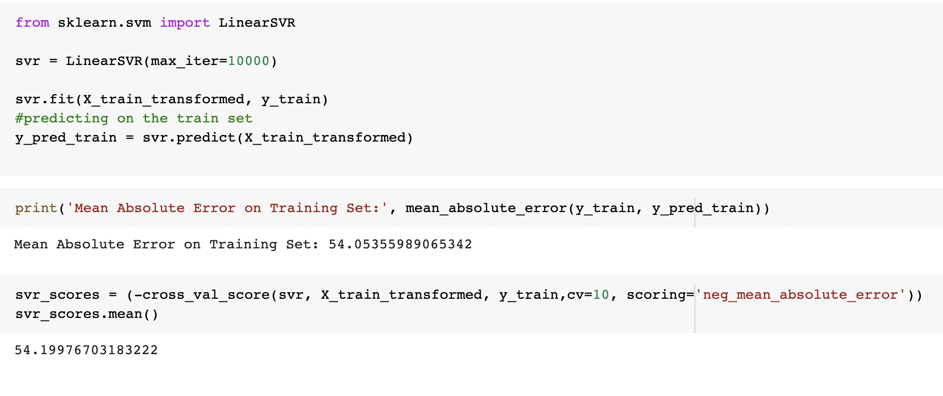

**Milestone 5**

**Implementation of Selected Models**

**Decision Tree**

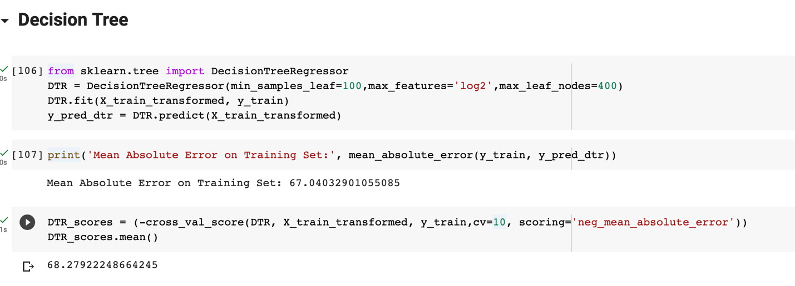

**KNN**

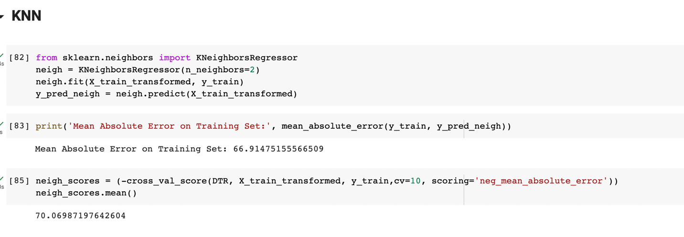

We also wanted to try using Stacking Regressor to check if our model can give better results or not. So, we tried stacking multiple regressor models.

**Stacking Regressor**

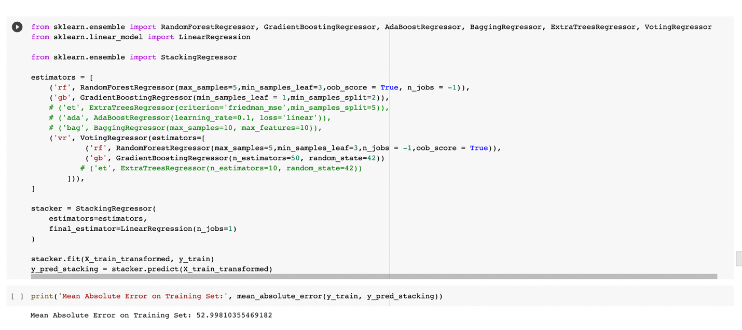

We also wanted to try blending 2 or more regressor models to check if we can get better results.

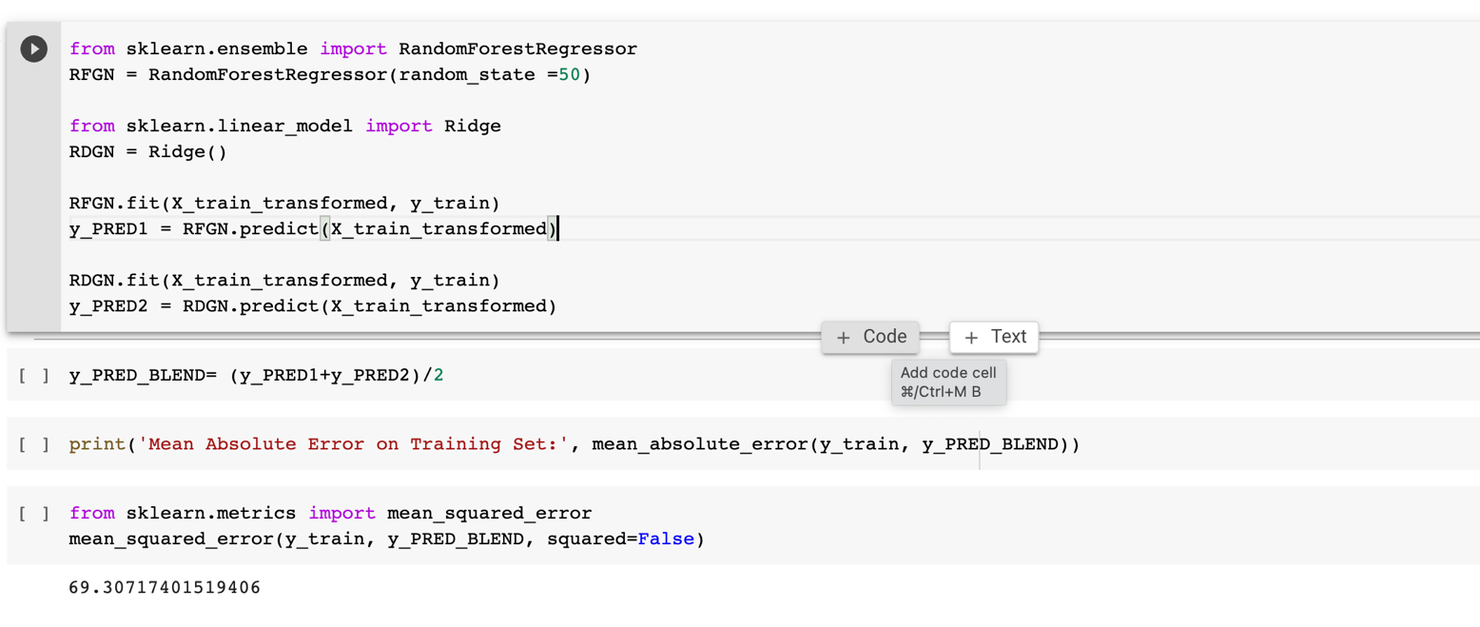

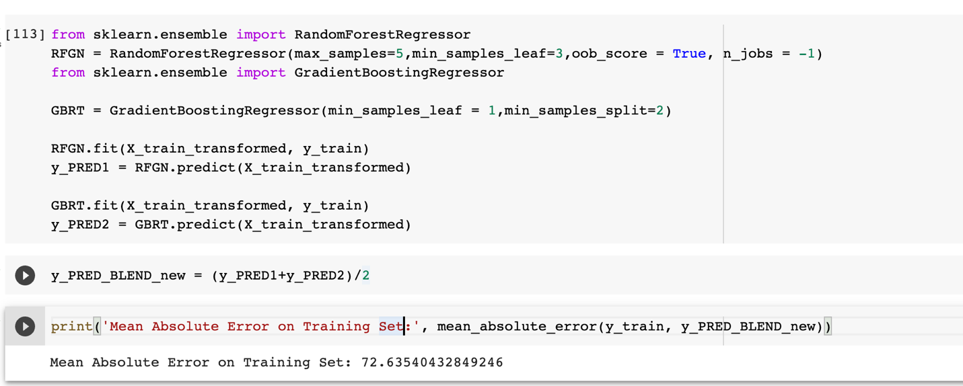

But it wasn’t giving us any better result than we already had.

After careful consideration we have come to a decision that Random Forest and Gradiant Boosting are our two best models till now.

And we will be moving forward with these two models.

Let’s try **HyperParameter Tuning** for both of these models

**RandomForest Regressor**

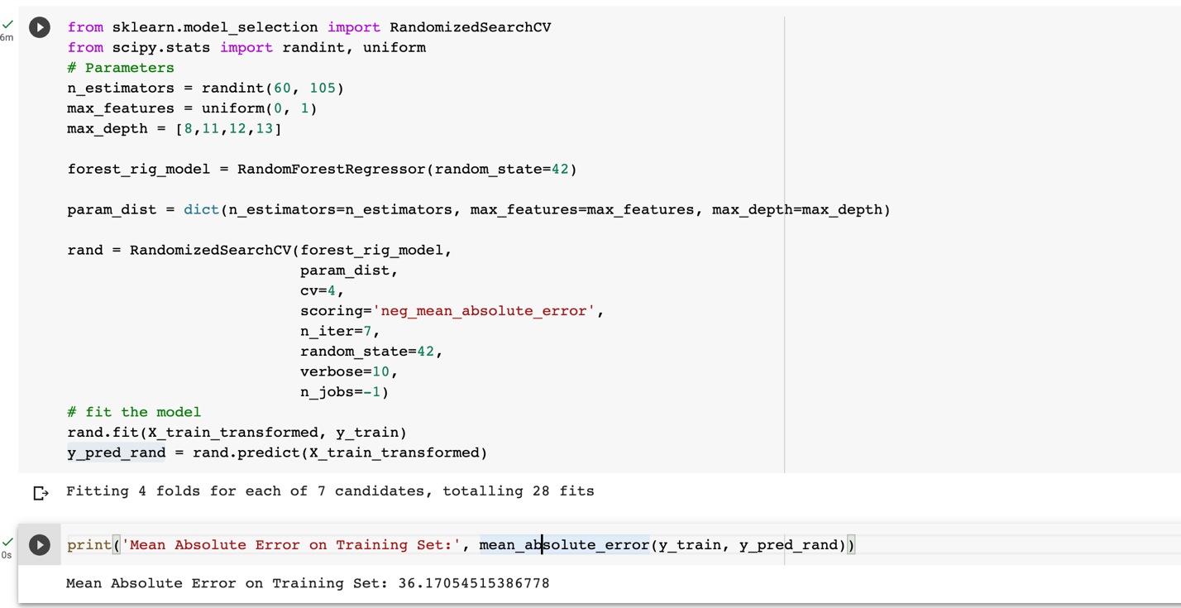

**GradiantBoosting Regressor**

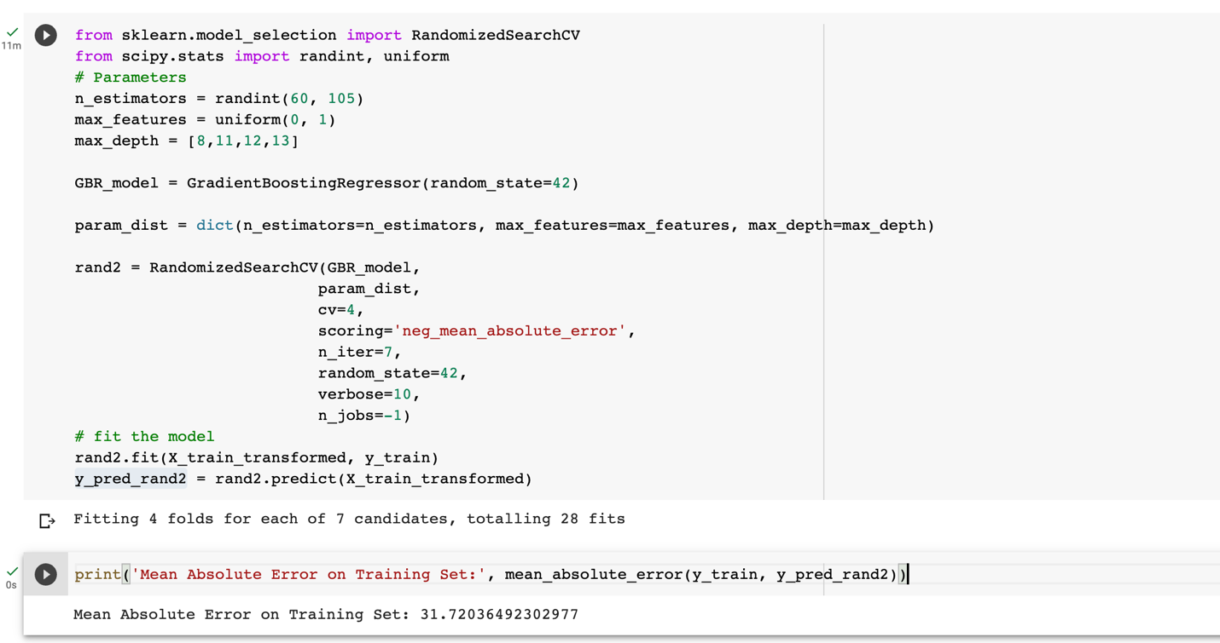

As you can see after hyper tuning few parameters, we are getting much better results.

And we would like to move forward with these two hyperparamter tuned models

**Milestone 6**

**Model Performance and Evaluation**

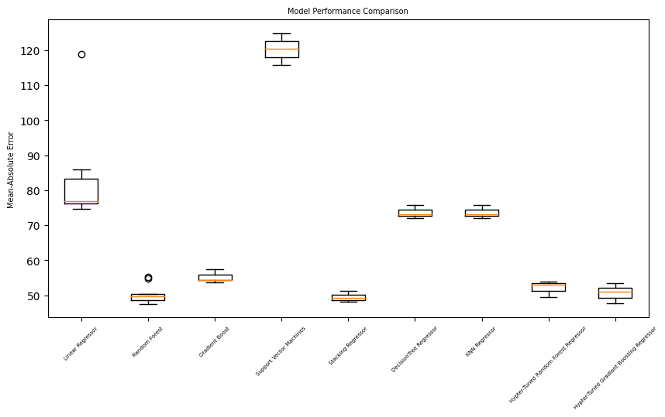

Comparing our final models

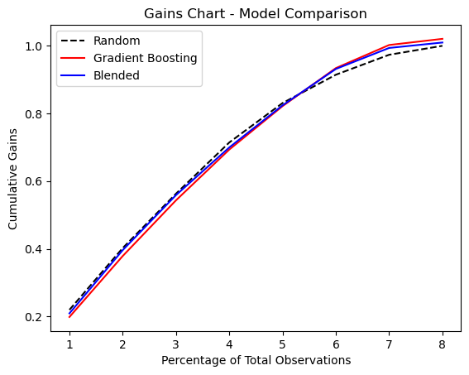

**Evaluation**

* The Support Vector Machines model had the highest mean absolute error of 120.30, indicating that it performed the worst in terms of prediction accuracy.
* The Linear Regressor model had the lowest mean absolute error of 82.68, indicating that it performed the best in terms of prediction accuracy.
* The Random Forest and Gradient Boost models had mean absolute errors of 50.29 and 55.01, respectively, indicating that they performed well in terms of prediction accuracy.
* The Stacking Regressor, Decision Tree Regressor, and KNN Regressor models had mean absolute errors of 49.48, 73.61, and 69.73, respectively, indicating that they performed moderately in terms of prediction accuracy.
* For the Stacking Regressor, we tried them using minimal parameters and with that we got mean absolute errors of 49.48 but when tried with multiple parameters it is not perfoming as good as before.
* The Hyper-Tuned Random Forest and Gradient Boosting Regressor models had mean absolute errors of 52.07 and 50.68, respectively, indicating that their hyperparameter tuning did somewhat improved their prediction accuracy.
* Hence, we can either use **Random Forest** and **Gradient Boosting** as it is as well as the tuned one.

**Why?**

* The reason for these models to perform better is because the data has a linear relationship between the predictor variable and the target variable.
* On the other hand, other models did not perform well is because it might be over fitting and were more sensible to outliers.

**Evaluation on Test Set**

* As discussed, before we choose **Hyperparameter Tuned Random Forest and Gradient Boosting Regressor** to be our final two models to fit on test data.
* On doing so we found out **Hyperparameter Tuned Random Forest** works even better on test data with MEA of 35.112731661 and R2 score of 0.87865454 but as for the **Hyperparameter Tuned Gradient Boosting Regressor** it might be over fitting on test data as it gave MEA of 20.5152476534 and R2 score of 0.9616383.
* So, for a last attempt we tried blending of both the above-mentioned models to see if we can get better result.

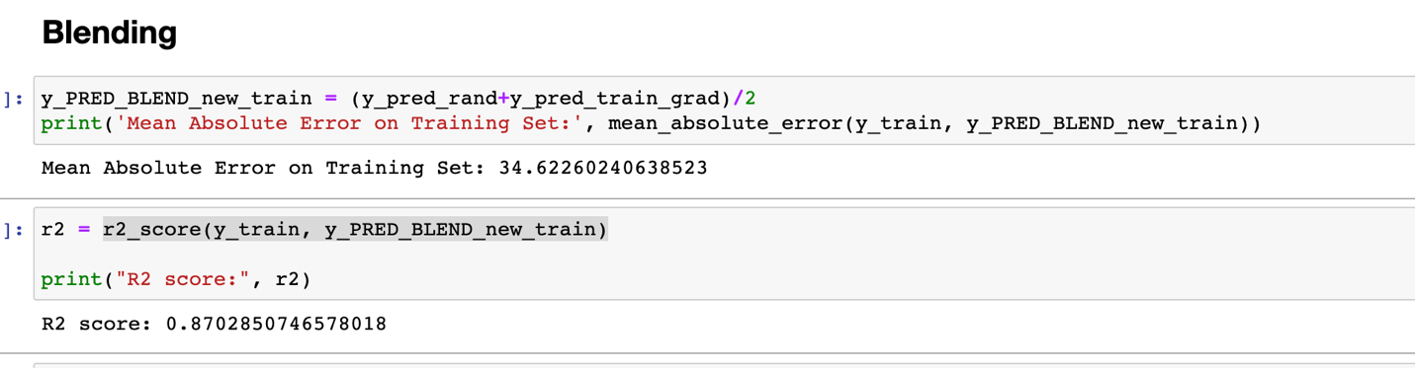

* So far **blended model** works good on train set. And we tested it on test set as well.

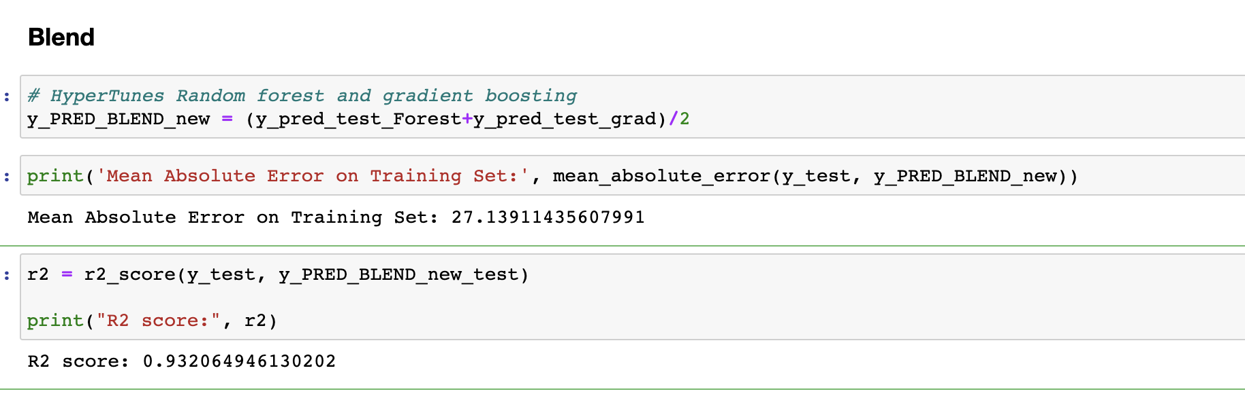

* And as we predicted it works even better on test set.
* So far Hyperparameter Tuned Random Forest and a Blended on works good on both train as well as test data.

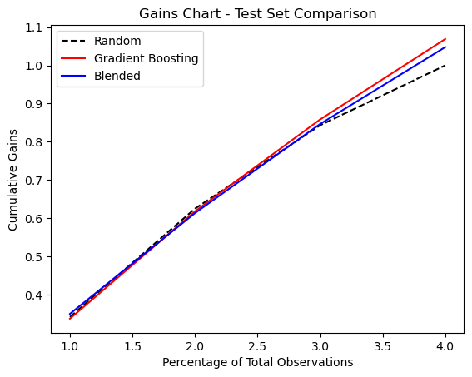

Here we have compared our top 3 models.

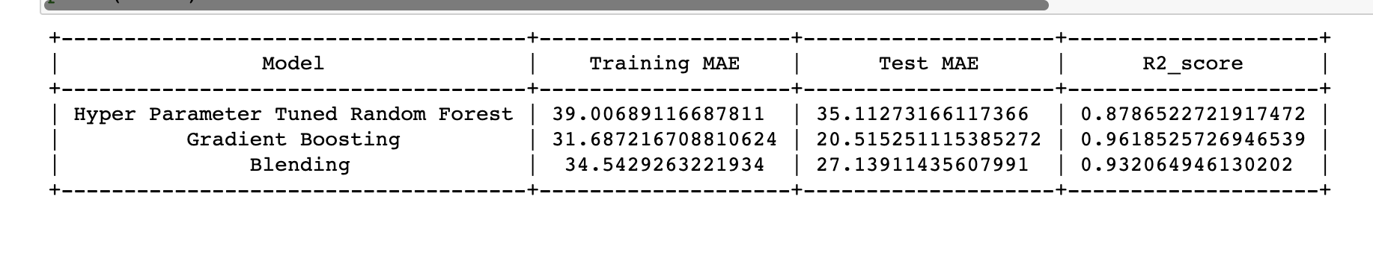

These were our final result for both test and train set for our top 3 models.

1. Blend ( Hyperparameter Tuned Random Forest and Gradient Boosting Regressor)
2. Hyperparameter Tuned Random Forest Regressor
3. Hyperparameter Tuned Gradient Boosting Regressor

**Evaluation on Test Set**

* Hyperparameter Tuned Random Forest Regressor works good on new and unseen data and might be the second best fit.
* Hyperparameter Tuned Gradient Boosting Regressor, is overfitting on new and unseen data.
* Blend ( Hyperparameter Tuned Random Forest and Gradient Boosting Regressor) is our best model so far performing very good on both train as well as test data.

**Drawbacks and Solution**

* One reason is outliers.
* Another is missing value. We tried to take care of all the missing values but there is so much you can do, we might have missed a few.
* Presence of biases is also one major drawback. For example, since data has been split, if the training data only includes listings form certain neighborhoods the models may not be able to predict accurately.
* Time and computational resources required to train and evaluate them may prevent the models to get higher accuracy especially for larger datasets and complex models.
* One potential solution is to try different model architectures such ad Deep Learning Models to improve accuracy.
* Techniques such as distributed training and parallel computing can be used to speed up training and evaluation.

**Future**

There is always room for improvement.

* Exploring additional feature engineering techniques.
* More ensemble models.
* Better hyperparameter optimization.
* Deep learning